**Praktikum RecyclerView**

**Mode CardView**

Pada modul ini kita akan membuat bentuk RecyclerView dengan komponen CardView**.**Komponen ini akan menampilkan data selayaknya sebuah kartu. Pendekatan ini hanya diperuntukkan bila item list memiliki lebih dari satu *action*.

1. Buka kembali project Recyclerview yang telah anda selesaikan seblumnya.
2. Masuk ke package res, kemudian anda buat kembali berkas layout xml dengan nama item_cardview_hero.

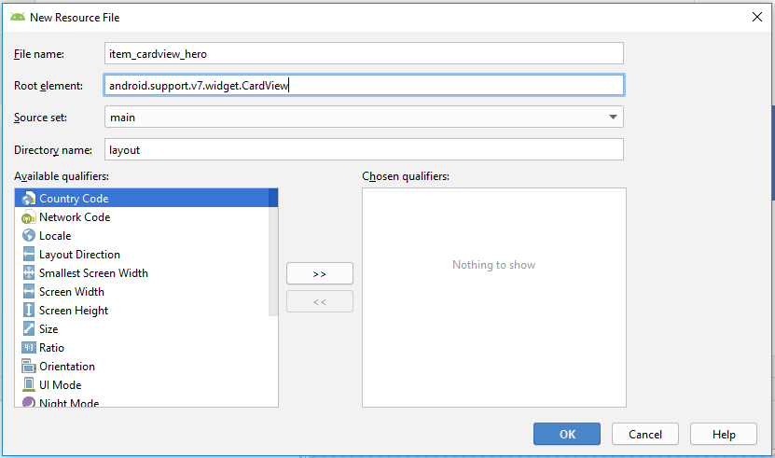

Setelah itu lengkapi kodenya menjadi seperti berikut :

|  |
| --- |
| 1. <?xml version="1.0" encoding="utf-8"?> 2. <android.support.v7.widget.CardView xmlns:android="http://schemas.android.com/apk/res/android" 3. xmlns:card_view="http://schemas.android.com/apk/res-auto" 4. xmlns:tools="http://schemas.android.com/tools" 5. android:id="@+id/card_view" 6. android:layout_width="match_parent" 7. android:layout_height="wrap_content" 8. **android:layout_gravity="center"** 9. **android:layout_marginLeft="8dp"** 10. **android:layout_marginTop="4dp"** 11. **android:layout_marginRight="8dp"** 12. **android:layout_marginBottom="4dp"** 13. **card_view:cardCornerRadius="4dp"**> 15. **<RelativeLayout** 16. **android:layout_width="match_parent"** 17. **android:layout_height="200dp"** 18. **android:padding="8dp">** 19. **<ImageView** 20. **android:id="@+id/img_item_photo"** 21. **android:layout_width="150dp"** 22. **android:layout_height="220dp"** 23. **android:layout_marginBottom="4dp"** 24. **android:scaleType="centerCrop"** 25. **tools:src="@color/colorAccent" />** 26. **<TextView** 27. **android:id="@+id/tv_item_name"** 28. **android:layout_width="match_parent"** 29. **android:layout_height="wrap_content"** 30. **android:layout_marginLeft="@dimen/activity_vertical_margin"** 31. **android:layout_marginTop="@dimen/activity_vertical_margin"** 32. **android:layout_marginRight="@dimen/activity_vertical_margin"** 33. **android:layout_marginBottom="8dp"** 34. **android:layout_toEndOf="@id/img_item_photo"** 35. **android:layout_toRightOf="@id/img_item_photo"** 36. **android:textSize="16sp"** 37. **android:textStyle="bold"** 38. **tools:text="@string/heroes_name" />** 39. **<TextView** 40. **android:id="@+id/tv_item_from"** 41. **android:layout_width="match_parent"** 42. **android:layout_height="match_parent"** 43. **android:layout_above="@+id/layout_button"** 44. **android:layout_below="@id/tv_item_name"** 45. **android:layout_marginLeft="@dimen/activity_vertical_margin"** 46. **android:layout_marginRight="@dimen/activity_vertical_margin"** 47. **android:layout_toEndOf="@id/img_item_photo"** 48. **android:layout_toRightOf="@id/img_item_photo"** 49. **android:ellipsize="end"** 50. **android:maxLines="5"** 51. **tools:text="@string/description" />** 52. **<LinearLayout** 53. **android:id="@+id/layout_button"** 54. **android:layout_width="match_parent"** 55. **android:layout_height="wrap_content"** 56. **android:layout_alignParentBottom="true"** 57. **android:layout_marginStart="@dimen/activity_horizontal_margin"** 58. **android:layout_marginLeft="@dimen/activity_horizontal_margin"** 59. **android:layout_toEndOf="@id/img_item_photo"** 60. **android:layout_toRightOf="@id/img_item_photo"** 61. **android:orientation="horizontal">** 62. **<Button** 63. **android:id="@+id/btn_set_favorite"** 64. **style="@style/Widget.AppCompat.Button.Colored"** 65. **android:layout_width="match_parent"** 66. **android:layout_height="wrap_content"** 67. **android:layout_weight="1"** 68. **android:text="@string/favorite"** 69. **android:textSize="12sp" />** 70. **<Button** 71. **android:id="@+id/btn_set_share"** 72. **style="@style/Widget.AppCompat.Button.Colored"** 73. **android:layout_width="match_parent"** 74. **android:layout_height="wrap_content"** 75. **android:layout_weight="1"** 76. **android:text="@string/share"** 77. **android:textSize="12sp" />** 78. **</LinearLayout>** 79. **</RelativeLayout>** 80. </android.support.v7.widget.CardView> |

1. Setelah selesai, buat kembali kelas Adapter dengan nama CardViewHeroAdapter.

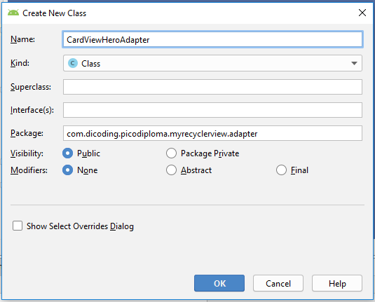

Kemudian kita lakukan hal yang sama dengan pembuatan LisHeroAdapter. Lengkapi kodenya menjadi seperti berikut:

|  |
| --- |
| Java |
| 1. public class CardViewHeroAdapter **extends RecyclerView.Adapter<CardViewHeroAdapter.CardViewViewHolder>{** 2. **}** |

|  |
| --- |
| Kotlin |
| 1. class CardViewHeroAdapter :**RecyclerView.Adapter<CardViewHeroAdapter.CardViewViewHolder>{** 2. **}** |

Setelah itu kita akan perbaiki eror dengan cara menekan **alt+enter**atau **klik lampu merahnya**.  Setelah memperbaiki maka akan menjadi seperi ini:

|  |
| --- |
| Java |
| 1. public class CardViewHeroAdapter extends RecyclerView.Adapter<CardViewHeroAdapter.CardViewViewHolder>{ 2. **@NonNull** 3. **@Override** 4. **public CardViewViewHolder onCreateViewHolder(@NonNull ViewGroup viewGroup, int i) {** 5. **return null;** 6. **}** 7. **@Override** 8. **public void onBindViewHolder(@NonNull CardViewViewHolder cardViewViewHolder, int i) {** 9. **}** 10. **@Override** 11. **public int getItemCount() {** 12. **return 0;** 13. **}** 14. **public class CardViewViewHolder extends RecyclerView.ViewHolder {** 15. **public CardViewViewHolder(@NonNull View itemView) {** 16. **super(itemView);** 17. **}** 18. **}** 19. } |

|  |
| --- |
| Kotlin |
| 1. class CardViewHeroAdapter : RecyclerView.Adapter<CardViewHeroAdapter.CardViewViewHolder>() { 2. **override fun onCreateViewHolder(parent: ViewGroup, viewType: Int): CardViewViewHolder {** 3. **TODO("not implemented") //To change body of created functions use File | Settings | File Templates.** 4. **}** 5. **override fun onBindViewHolder(holder: CardViewViewHolder, position: Int) {** 6. **TODO("not implemented") //To change body of created functions use File | Settings | File Templates.** 7. **}** 9. **override fun getItemCount(): Int {** 10. **TODO("not implemented") //To change body of created functions use File | Settings | File Templates.** 11. **}** 12. **inner class CardViewViewHolder(itemView: View) : RecyclerView.ViewHolder(itemView) {** 13. **}** 14. } |

Kemudian buatlah dan constructor untuk list seperti ini:

|  |
| --- |
| Java |
| 1. public class CardViewHeroAdapter extends RecyclerView.Adapter<CardViewHeroAdapter.CardViewViewHolder>{ 2. **private ArrayList<Hero> listHero;** 3. **public CardViewHeroAdapter(ArrayList<Hero> list) {** 4. **this.listHero = list;** 5. **}** 7. ... 8. } |

|  |
| --- |
| Kotlin |
| 1. class CardViewHeroAdapter**(private val listHeroes: ArrayList<Hero>)** : RecyclerView.Adapter<CardViewHeroAdapter.CardViewViewHolder>() { 2. ... 3. } |

Setelah itu kita bisa melengkapi kode kode hasil dari turunan RecyclerView.Adapter. Maka kode lengkap dari kelas CardViewHeroAdapter sebagai berikut:

|  |
| --- |
| Java |
| 1. public class CardViewHeroAdapter extends RecyclerView.Adapter<CardViewHeroAdapter.CardViewViewHolder> { 2. private ArrayList<Hero> listHero; 4. public CardViewHeroAdapter(ArrayList<Hero> list) { 5. this.listHero = list; 6. } 8. @NonNull 9. @Override 10. public CardViewViewHolder onCreateViewHolder(@NonNull ViewGroup viewGroup, int viewType) { 11. **View view = LayoutInflater.from(viewGroup.getContext()).inflate(R.layout.item_cardview_hero, viewGroup, false);** 12. **return new CardViewViewHolder(view);** 13. } 15. @Override 16. public void onBindViewHolder(@NonNull **final** CardViewViewHolder **holder**, int **position**) { 18. **Hero hero = listHero.get(position);** 19. **Glide.with(holder.itemView.getContext())** 20. **.load(hero.getPhoto())** 21. **.apply(new RequestOptions().override(350, 550))** 22. **.into(holder.imgPhoto);** 23. **holder.tvName.setText(hero.getName());** 24. **holder.tvFrom.setText(hero.getFrom());** 25. **holder.btnFavorite.setOnClickListener(new View.OnClickListener() {** 26. **@Override** 27. **public void onClick(View v) {** 28. **Toast.makeText(holder.itemView.getContext(), "Favorite " +** 29. **listHero.get(holder.getAdapterPosition()).getName(), Toast.LENGTH_SHORT).show();** 30. **}** 31. **});** 32. **holder.btnShare.setOnClickListener(new View.OnClickListener() {** 33. **@Override** 34. **public void onClick(View v) {** 35. **Toast.makeText(holder.itemView.getContext(), "Share " +** 36. **listHero.get(holder.getAdapterPosition()).getName(), Toast.LENGTH_SHORT).show();** 37. **}** 38. **});** 39. } 41. @Override 42. public int getItemCount() { 43. **return listHero.size();** 44. } 46. class CardViewViewHolder extends RecyclerView.ViewHolder { 47. **ImageView imgPhoto;** 48. **TextView tvName, tvFrom;** 49. **Button btnFavorite, btnShare;** 50. **CardViewViewHolder(View itemView) {** 51. **super(itemView);** 52. **imgPhoto = itemView.findViewById(R.id.img_item_photo);** 53. **tvName = itemView.findViewById(R.id.tv_item_name);** 54. **tvFrom = itemView.findViewById(R.id.tv_item_from);** 55. **btnFavorite = itemView.findViewById(R.id.btn_set_favorite);** 56. **btnShare = itemView.findViewById(R.id.btn_set_share);** 57. **}** 58. } 59. } |

|  |
| --- |
| Kotlin |
| 1. class CardViewHeroAdapter(private val listHeroes: ArrayList<Hero>) : RecyclerView.Adapter<CardViewHeroAdapter.CardViewViewHolder>() { 3. override fun onCreateViewHolder(parent: ViewGroup, viewType: Int): CardViewViewHolder { 4. **val view: View = LayoutInflater.from(parent.context).inflate(R.layout.item_cardview_hero, parent, false)** 5. **return CardViewViewHolder(view)** 6. } 8. override fun onBindViewHolder(**holder**: CardViewViewHolder, **position**: Int) { 9. **val (name, from, photo) = listHero[position]** 10. **Glide.with(holder.itemView.context)** 11. **.load(photo)** 12. **.apply(RequestOptions().override(350, 550))** 13. **.into(holder.imgPhoto)** 14. **holder.tvName.text = name** 15. **holder.tvFrom.text = from** 16. **holder.btnFavorite.setOnClickListener { Toast.makeText(holder.itemView.context, "Favorite " + listHero[holder.adapterPosition].name, Toast.LENGTH_SHORT).show() }** 17. **holder.btnShare.setOnClickListener { Toast.makeText(holder.itemView.context, "Share " + listHero[holder.adapterPosition].name, Toast.LENGTH_SHORT).show() }** 18. **holder.itemView.setOnClickListener { Toast.makeText(holder.itemView.context, "Kamu memilih " + listHero[holder.adapterPosition].name, Toast.LENGTH_SHORT).show() }** 19. } 21. override fun getItemCount(): Int { 22. **return listHeroes.size** 23. } 25. inner class CardViewViewHolder(itemView: View) : RecyclerView.ViewHolder(itemView) { 26. **var imgPhoto: ImageView = itemView.findViewById(R.id.img_item_photo)** 27. **var tvName: TextView = itemView.findViewById(R.id.tv_item_name)** 28. **var tvFrom: TextView = itemView.findViewById(R.id.tv_item_from)** 29. **var btnFavorite: Button = itemView.findViewById(R.id.btn_set_favorite)** 30. **var btnShare: Button = itemView.findViewById(R.id.btn_set_share)** 31. } 32. } |

1. Setelah selesai, kita perlu menambahkan satu metode lagi untuk menampilkan bentuk RecyclerView ini. Caranya lengkapi kode pada MainActivity menjadi seperti berikut:

|  |
| --- |
| Java |
| 1. **private void showRecyclerCardView(){** 2. **rvHeroes.setLayoutManager(new LinearLayoutManager(this));** 3. **CardViewHeroAdapter cardViewHeroAdapter = new CardViewHeroAdapter(list);** 4. **rvHeroes.setAdapter(cardViewHeroAdapter);** 5. **}** |

|  |
| --- |
| Kotlin |
| 1. **private fun showRecyclerCardView() {** 2. **rvHeroes.layoutManager = LinearLayoutManager(this)** 3. **val cardViewHeroAdapter = CardViewHeroAdapter(list)** 4. **rvHeroes.adapter = cardViewHeroAdapter** 5. **}** |

Dan update metode onOptionsItemSelected() menjadi seperti berikut:

|  |
| --- |
| Java |
| 1. public void setMode(int selectedMode) { 2. switch (selectedMode) { 3. case R.id.action_list: 4. showRecyclerList(); 5. break; 7. case R.id.action_grid: 8. showRecyclerGrid(); 9. break; 11. case R.id.action_cardview: 12. **showRecyclerCardView();** 13. break; 14. } 15. } |

|  |
| --- |
| Kotlin |
| 1. private fun setMode(selectedMode: Int) { 2. when (selectedMode) { 3. R.id.action_list -> { 4. showRecyclerList() 5. } 7. R.id.action_grid -> { 8. showRecyclerGrid() 9. } 11. R.id.action_cardview -> { 12. **showRecyclerCardView()** 13. } 14. } 15. } |

1. Jalankan kembali aplikasinya. Seharusnya Anda sudah bisa menampilkan tiga bentuk RecyclerView yang telah kita rencanakan sebelumnya.
2. Untuk mempercantik tampilan dan memenuhi target di awal, kita akan menambah metode untuk mengubah judul halaman setiap melakukan perubahan bentuk dari RecyclerView.

|  |
| --- |
| Java |
| 1. private void setActionBarTitle(String title) { 2. if (getSupportActionBar() != null) { 3. getSupportActionBar().setTitle(title); 4. } 5. } |

|  |
| --- |
| Kotlin |
| 1. private fun setActionBarTitle(title: String) { 2. if (supportActionBar != null) { 3. (supportActionBar as ActionBar).title = title 4. } 5. } |

Kemudian tambahkan variable baru diatas metode onCreate() seperti berikut:

|  |
| --- |
| Java |
| 1. private String title = "Mode List"; |

|  |
| --- |
| Kotlin |
| 1. private var title: String = "Mode List" |

Dan kita update kembali metode setMode sehingga menjadi seperti berikut :

|  |
| --- |
| Java |
| 1. public void setMode(int selectedMode) { 2. switch (selectedMode) { 3. case R.id.action_list: 4. **title = "Mode List";** 5. showRecyclerList(); 6. break; 8. case R.id.action_grid: 9. **title = "Mode Grid";** 10. showRecyclerGrid(); 11. break; 13. case R.id.action_cardview: 14. **title = "Mode CardView";** 15. showRecyclerCardView(); 16. break; 17. } 18. } |

|  |
| --- |
| Kotlin |
| 1. private fun setMode(selectedMode: Int) { 2. when (selectedMode) { 3. R.id.action_list -> { 4. **title = "Mode List"** 5. showRecyclerList() 6. } 8. R.id.action_grid -> { 9. **title = "Mode Grid"** 10. showRecyclerGrid() 11. } 13. R.id.action_cardview -> { 14. **title = "Mode CardView"** 15. showRecyclerCardView() 16. } 17. } 18. } |

Dan pada metode onCreate() tambahkan baris ini setActionBarTitle("Mode List");sebelum kita memanggil metode showRecyclerList();.

|  |
| --- |
| Java |
| 1. @Override 2. protected void onCreate(Bundle savedInstanceState) { 3. super.onCreate(savedInstanceState); 4. setContentView(R.layout.activity_main); 5. **setActionBarTitle(title);** 7. ... 8. } |

|  |
| --- |
| Kotlin |
| 1. override fun onCreate(savedInstanceState: Bundle?) { 2. super.onCreate(savedInstanceState) 3. setContentView(R.layout.activity_main) 4. **setActionBarTitle(title)** 6. ... 7. } |

1. Jalankan kembali aplikasinya. Sekarang judul halaman akan berubah seiring perubahan bentukRecyclerView**.**

